**Batch: B-1 Roll Number: 16010422234 Name: Chandana Ramesh Galgali**

**Experiment Number: 7 - Measuring Network Performance**

**Aim of the Experiment:** To get familiar with the concept of network performance evaluation, and different related metrics; get an overview on bandwidth sharing by multiple traffic flows; identify bottlenecks in a network.

**Program/ Steps:**

1. Consider a local area network connecting node numbers 3, 4, 5. This LAN is connected to two external servers(node no.0 and node no.1) through a router(node no.2).

2. Here in this network node no. 0 is connected to node no.2 by a duplex link and node no.1 is connected to node no.2 by a duplex link. Again, node no.2 and node no.3 are connected to each other with two simplex links thereby allowing bi-directional data transmission.

3. The server at node no.0 is running an application on TCP/IP and sending data to node no.4.

4. For the two simplex links between node 2 and node 3, different possible values for the link bandwidth, propagation delay, queue type are shown in the right hand side panel.

5. Altering any of these parameters affects the throughput of the network(which is simply no. of bytes received per unit time). The different throughput curves can be viewed in the right hand side panel.

**Output/Result:**

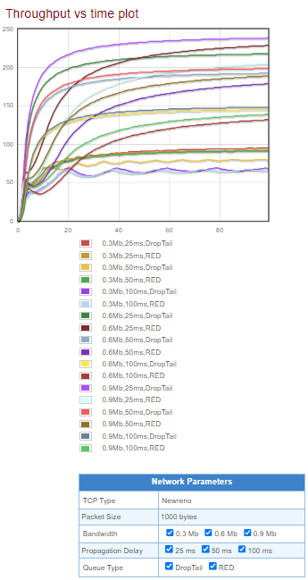

**Self-evaluation:**

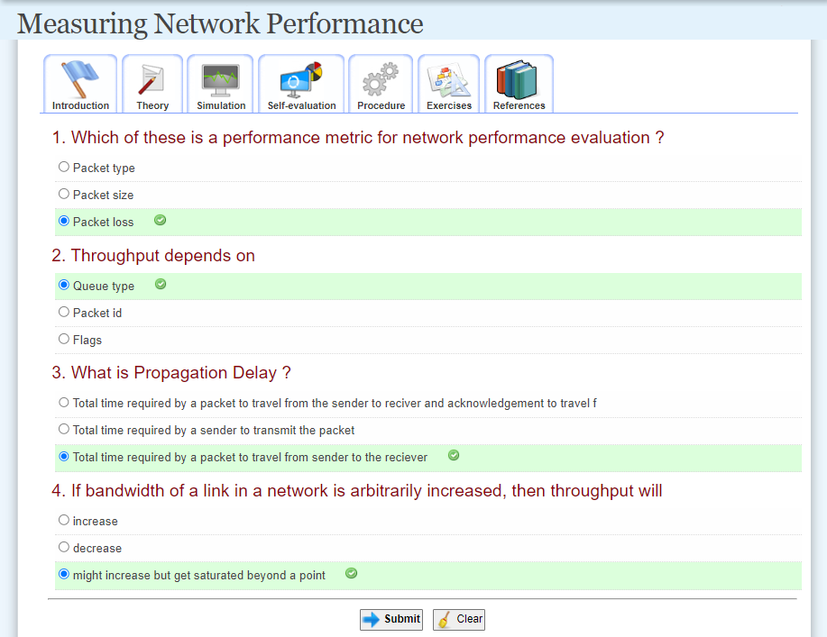

**Post Lab Question-Answers:**

**1) The experiment demonstrated corresponds to which layer?**

**Ans.** The experiment demonstrated in the given scenario corresponds to the network layer.

**2) List the protocols belonging to the layer.**

**Ans.** The network layer of the network stack includes several protocols. Some of the commonly used protocols at the network layer are:

1. Internet Protocol (IP): The IP protocol is responsible for addressing and routing packets across different networks in an internetwork.

2. Internet Control Message Protocol (ICMP): ICMP is used for error reporting, network diagnostics, and management functions. It is commonly used for tasks such as ping and traceroute.

3. Internet Group Management Protocol (IGMP): IGMP is used by hosts and adjacent routers to establish multicast group memberships on a network.

4. Address Resolution Protocol (ARP): ARP is used to map an IP address to a physical (MAC) address on a local network.

5. Routing Information Protocol (RIP): RIP is a distance-vector routing protocol used for routing within an autonomous system.

6. Open Shortest Path First (OSPF): OSPF is a link-state routing protocol used for routing within an autonomous system.

7. Border Gateway Protocol (BGP): BGP is an exterior gateway protocol used for routing between autonomous systems on the Internet.

**3) List any two functions of that layer.**

**Ans.** Two functions of the network layer in the network stack are:

1. Routing: The network layer is responsible for determining the optimal path for data packets to travel from the source to the destination across different networks. It uses routing protocols and algorithms to make decisions on how to forward packets based on factors such as network congestion, link availability, and network topology.

2. Addressing: The network layer assigns unique logical addresses, such as IP addresses, to devices connected to the network. These addresses are used to identify the source and destination of data packets. The network layer ensures that packets are correctly addressed and routed to the intended destination based on the assigned addresses.

**Outcomes: Build the skills of subnetting and routing mechanisms.**

**Conclusion (based on the Results and outcomes achieved):**

We got familiar with the concept of network performance evaluation, and different related metrics. We also got an overview on bandwidth sharing by multiple traffic flows. We could successfully identify bottlenecks in a network.

**References:**

**Books/ Journals/ Websites:**

1. <http://vlabs.iitkgp.ernet.in/ant/3/>
2. Data Communication and Networking, Behrouz A Forouzan, Tata Mcgraw Hill, 4th edition, 2009
3. Computer Networking: A Top-Down Approach Featuring, James Kurose, Keith Ross, Pearson (2005), 3rd Edition
4. [Introduction to NS by Adam Greenhalgh](http://www.cs.ucl.ac.uk/staff/a.greenhalgh/teaching/msctelecomsns/MScTelecomsNS2005.pdf.)
5. [How to measure packet loss rate, jitter, and end-to-end delay for UDP-based applications?](http://hpds.ee.ncku.edu.tw/~smallko/ns2/tool_en.htm)
6. [Ikram Ud din and Saeed Mahfooz. "Performance Evaluation of Different Ethernet LANs Connected by Switches and Hubs", European Journal of Scientific Research.Vol 37 No.3(2009),pp.461-470](http://www.eurojournals.com/ejsr_37_3_11.pdf)
7. ["Performance Evaluation of Computer Networks", Prof. Bob Kinicki, Computer Science Department, Worcester Polytechnic Institute (WPI)](http://web.cs.wpi.edu/~rek/PerformanceMeasurement.ppt.)
8. [Network Performance Evaluation](http://en.wikipedia.org/wiki/Network_performance)